**BDI-3 Overview**

The Battelle Developmental Inventory, 3rd Edition (BDI-3) is a standardized assessment instrument. This means that it is intended to be given the same way, following the same instructions and procedures each time it is given. It is also **norm-based**, meaning that the scores are generated by the child’s performance based on the performance of same-aged peers on the same items.

Before a new norm-based tool is able to be used, the tool’s publisher has to go through a rigorous process to demonstrate why the group used to norm the new tool were representative of the population.

It’s also important to note that the total scores for a child with delays is typically less than the score for the individual domains. This is normal for norm referenced tests.

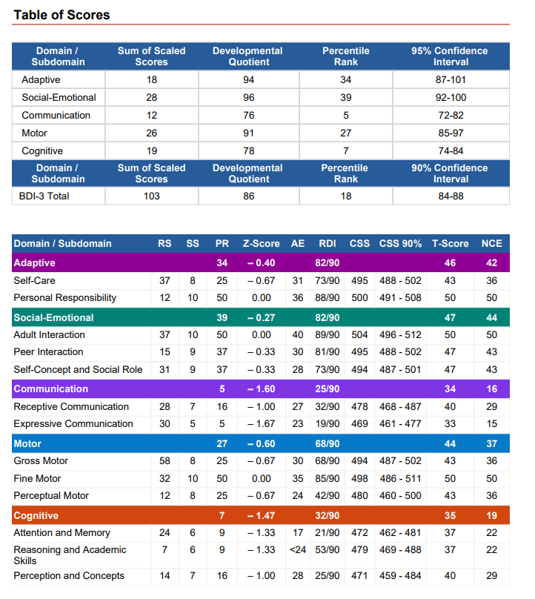

**Score Descriptors**

**Raw Score (RS)**

* Description from the BDI-3 report: *A raw score is the summation of the points given for each item within a subdomain or area.*
* What does this mean for TEIS: *This information is available at the sub-domain level. It simply tells you how many points the child scored in that sub-domain. The report does not tell you how many were possible.*

**SS - Standard Score or Scaled Score and Developmental Quotients (DQ)**

* Description from the BDI-3 report: *Domain Standard Scores (SS), also called Developmental Quotients (DQ), have a mean of 100 and standard deviation of 15. A Domain SS of 85 falls at the 16th percentile, 100 at the 50th, and a SS of 115 falls at the 84th percentile. Subdomain scaled scores have a mean of 10 and standard deviation of 3. A scaled score of 7 falls at the 16th percentile, a scaled score of 10 falls at the 50th, and a scaled score of 13 falls at the 84th percentile.*
* What does this mean for TEIS: Standard score or Scale Score (SS) means the scores will be converted to make them comparable.
  + Each domain has a different number of points possible and/or a different number of items assessed, based on the age of the child and their performance on the test, so something has to be done to be able to compare the domains to each other.
  + For DQ scores, the BDI test has done the math to make the mean (average) for the domain equal to 100.
  + Whenever you see the term “standard deviations” it is referring to where someone falls on a bell curve (see image below).
  + A bell curve describes the distribution of a population. For the purposes of using the BDI-3 for early intervention to evaluation a child’s development, the majority of typically developing children would fall in the middle of the curve (the highest point). The right side of the curve would refer to children who gain skills early and the left side of the curve relates to children who are exhibiting delays.
  + The hash marks (-3, -2, -1 and 1, 2, 3) refer to standard deviations from the norm (middle) and is a way of expressing the performance.
    - The majority of people assessed on a standardized test are expected to perform near the middle. The further you go from either side of the middle, the more exceptional the performance.
  + Therefore, what this means, is that the BDI has taken the child’s performance on each domain and sub-domain, made them comparable to each other (equal) and then placed the child on a bell curve to see how they compare to the population.
  + **For TEIS eligibility purposes, DQ scores of 70-78 equal a 25% delay in a domain, and DQ scores of 70 or lower equal a 40% delay**.
* The BDI-3 manual notes that the DQ scores is the most reliable of all the score information available for the BDI-3

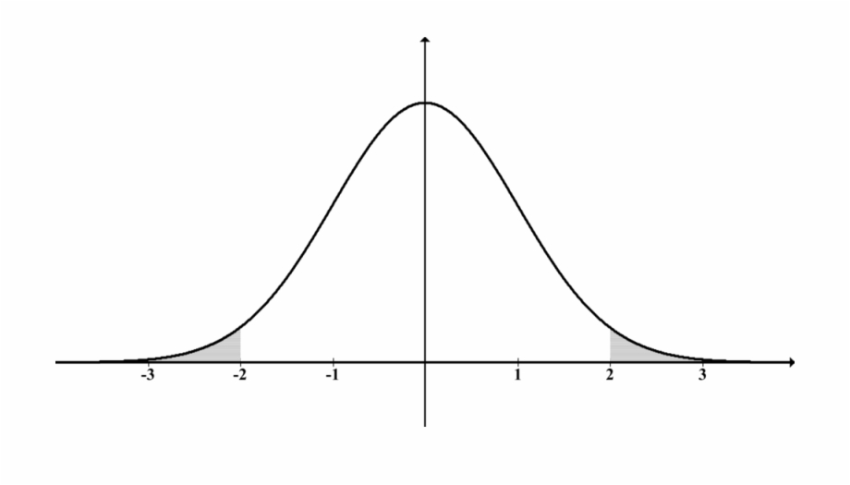

**PR - Percentile Rank**

* Description from the BDI-3 report: *Percentile rank scores reflect a child’s relative position within the normative sample for his or her age group.*
* What does this mean for TEIS? This means that the child’s score will be compared to the scores of all of the same-aged children who were used in the normative sample (development of the test) and it will show how this child ranked in comparison. A percentile rank of 35 means that they performed better than 35% of same-aged peers but lower than 65% their same-age peers.

**Z-Score**

* Description from the BDI-3 report: *A Z-Score is a score that is measured in terms of standard deviations from the average, or mean, and is expressed as 0, positive numbers, or negative numbers. A Z-score of 0 falls at the mean.*
* What does this mean for TEIS? This again refers to being able to compare scores along a bell curve. In this instance, the average score for the domain becomes the middle point (instead of 100 in the instance of DQ scores) and the standard deviations (-3, -2, -1 or 1, 2, 3) from the average are calculated. This is less helpful than the DQ score because each domain will have a different average (middle point), making the scores less easily comparable across domains.

**AE - Age Equivalent**

* Description from the BDi-3 report: *Age equivalent indicates the age at which a specific raw score is equal to the median (50th percentile) obtained by children of a given age.*
* What does this mean for TEIS? This one sounds simple but is easily misinterpreted. It is NOT referring to the “developmental age” at which a child is functioning based on their scores. It is referring to the age at which the child’s current raw scores on the day of evaluation would put them at the 50% percentile rank (middle of the bell curve).
  + Riverside recommends using caution when reviewing age equivalents, not only because of the possibility of misinterpretation but also because developmental changes can occur rapidly.

**CSS - Change Sensitive Score**

* Description from the BDI-3 report:*The CSS represents a discrete point on the developmental milestone continuum underlying each subdomain. The CSS scale is centered so that a score of 500 on each subdomain represents the developmental level of a typical 36-month-old child and is best used to compare two administrations of the BDI-3 in order to assess change over time.*
* What does this mean for TEIS? This allows a child’s progress on the BDI-3 to be compared over time, even though the child is getting older and may be assessed on different items than they were when they first came into the program. The CSS score also means that two children who obtain the same subdomain CSS score have a comparable level of development in that subdomain, regardless of age. In addition, the amount of developmental growth required to achieve a change in the CSS is equivalent; a 10-point difference between a CSS of 450 and 460 represents the same amount of growth or change as a CSS of 500 and 510. This score will allow IFSP teams to track developmental progress over time.

**RDI - The Relative Developmental Index (RDI)**

* Description from the BDI-3 report: The Relative Developmental Index (RDI) is expressed as a fraction, with the bottom number as 90, or 90% proficiency for the examinee’s age group. The numerator is a number ranging from 0 to 100 and expresses the examinee’s proficiency.
* What does this mean for TEIS? TEIS does not use this measure at this time.

**T-Score**

* Description from the BDI-3 report: A T-Score is a score that has a mean of 50 and a standard deviation of 10.
* What does this mean for TEIS? TEIS does not use this measure at this time.

**NCE - The Normal Curve Equivalent**

* Description from the BDI-3 report: The Normal Curve Equivalent is another commonly reported type of standard score that has a mean of 50 and a standard deviation of 21.06.
* What does this mean for TEIS? TEIS does not use this measure at this time.